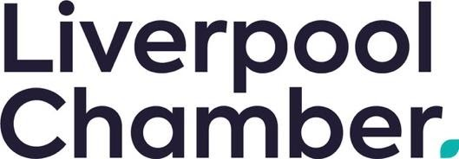

**JOB DESCRIPTION**

**Events Coordinator**

**Full Time | Salary: £25,000**

**About this role**

This dynamic job will play a key role in the planning and execution of Liverpool Chamber’s portfolio of events, while also supporting our marketing campaigns and providing essential administrative leadership for the delivery.

This is an exciting opportunity to work under the direction of the Events Manager to ensure that all events provide a consistently high level of quality and achieve the requirements of the event specification.

These events will vary from large corporate hospitality events to commercial and project-based workshops, networking sessions, conferences and training sessions.

**Key accountabilities include:**

* Support the planning, coordination and delivery of a range of in-person and virtual events from concept through to completion
* Liaise with venues, suppliers, speakers, and internal stakeholders
* Support delivery of event logistics, budgets, timelines, and on-site support
* Monitor event success and gather feedback for continual improvement
* Assist in the creation and scheduling of marketing content across digital channels (email, social media, website)
* Coordinate the design and production of event-related promotional materials
* Support audience engagement and lead generation efforts
* Maintain and update event and campaign calendars
* Provide general administrative support to the events and marketing function
* Maintain databases, records, and event registration systems
* Prepare reports, presentations, and other documentation as required
* Support invoice processing and budget tracking

**Person Specification – Events Coordinator**

**Essential:**

* Proven experience in events coordination, marketing support, or a similar role
* Experience of producing copy for social media platforms
* Strong organisational and time-management skills
* Clear written and verbal communication
* Confident using email and phone
* Competent using digital tools such as Microsoft Office, Canva, Eventbrite, Mailchimp, or similar
* Able to work independently and in a team
* Good attention to detail
* Positive, proactive attitude and willingness to learn
* Some experience in admin, customer service, or event support
* Friendly, reliable, and approachable

**Desirable:**

* Degree or Level 3-equivalent qualification related to events, marketing or public relations
* Familiarity with local business or community groups
* Basic understanding of business support and networking events
* Knowledge of the Liverpool City Region
* Experience with event planning tools or software such as Eventbrite and Zoom